**INDEX**

**Planning and Analysis:** **2**

**Design:** **4**

System Flow Diagram 4

ER Diagram 5

Data Flow Diagram (DFD) 6

Use Case Diagram 7

**Coding, Testing & Implementation:** **8**

Coding: 8

Implementation: 13

Testing and Quality Assurance 15

Online Reservation and Booking System

Objectives: In this system, the administrator offers various reservation systems such as resort vehicles, conference halls, etc. The administrator implements an implementation check-in or check-out facility, records the customer details, the customer manages the booking easily, adapts the pricing, and makes sure about online payment, and customization of reservations.

# Planning and Analysis:

Requirement gathering and analysis is a crucial phase in the development of a hotel reservation system website. It involves identifying and documenting the needs, expectations, and constraints of stakeholders, including customers, hotel staff, and management. Here are the key steps involved in requirement gathering and analysis:

* Identify Stakeholders: Determine the primary stakeholders involved in the hotel reservation system website project, such as customers, hotel staff, management, and administrators. Understand their roles, responsibilities, and objectives to ensure that their requirements are properly addressed.
* Conduct Interviews and Surveys: Engage with stakeholders through interviews or surveys to gather their perspectives on the existing reservation process, pain points, and desired improvements. Identify their specific requirements related to user experience, functionality, security, and integration with other systems.
* Analyze Business Processes: Study and analyze the existing hotel reservation processes, including room availability management, reservation handling, payment processing, and reporting. Identify any inefficiencies, bottlenecks, or areas for improvement that the new system should address.
* Define Functional Requirements: Based on stakeholder inputs and process analysis, define the functional requirements of the hotel reservation system. This includes features like user registration and login, search and filtering options, real-time room availability, reservation management, secure payment processing, reporting and analytics, and integration with other systems.
* Specify Non-functional Requirements: Identify and document the non-functional requirements of the system, such as performance, scalability, security, usability, accessibility, and compatibility across different devices and browsers.

These requirements ensure that the system meets the necessary quality attributes.

* Prioritize Requirements: Prioritize the identified requirements based on their importance, urgency, and feasibility. Collaborate with stakeholders to determine the critical features and functionalities that should be included in the initial release, as well as those that can be considered for future iterations.
* Document Requirements: Create detailed requirement specifications, including use cases, user stories, functional and non-functional requirements, system diagrams, and UI mockups. Documenting requirements helps ensure a shared understanding among the development team and stakeholders.
* Validate Requirements: Validate the documented requirements with stakeholders to confirm their accuracy, completeness, and alignment with their expectations. Incorporate their feedback and make necessary revisions as needed.
* Requirement Traceability: Establish traceability between requirements and project objectives to ensure that all identified requirements contribute to achieving the desired outcomes. This helps in tracking the progress of implementation and assessing the impact of any changes.
* Review and Approval: Conduct formal reviews and seek approval from stakeholders, including hotel management and other relevant parties, to ensure that the requirements are comprehensive and aligned with their expectations before proceeding to the development phase.

# Design:

### System Flow Diagram

A system flow diagram, also known as a system flowchart or system process diagram, is a visual representation of the flow of information, data, and processes within a system or software application. It provides a high-level overview of how different components or modules interact and exchange data to accomplish specific tasks or achieve the system's objectives.

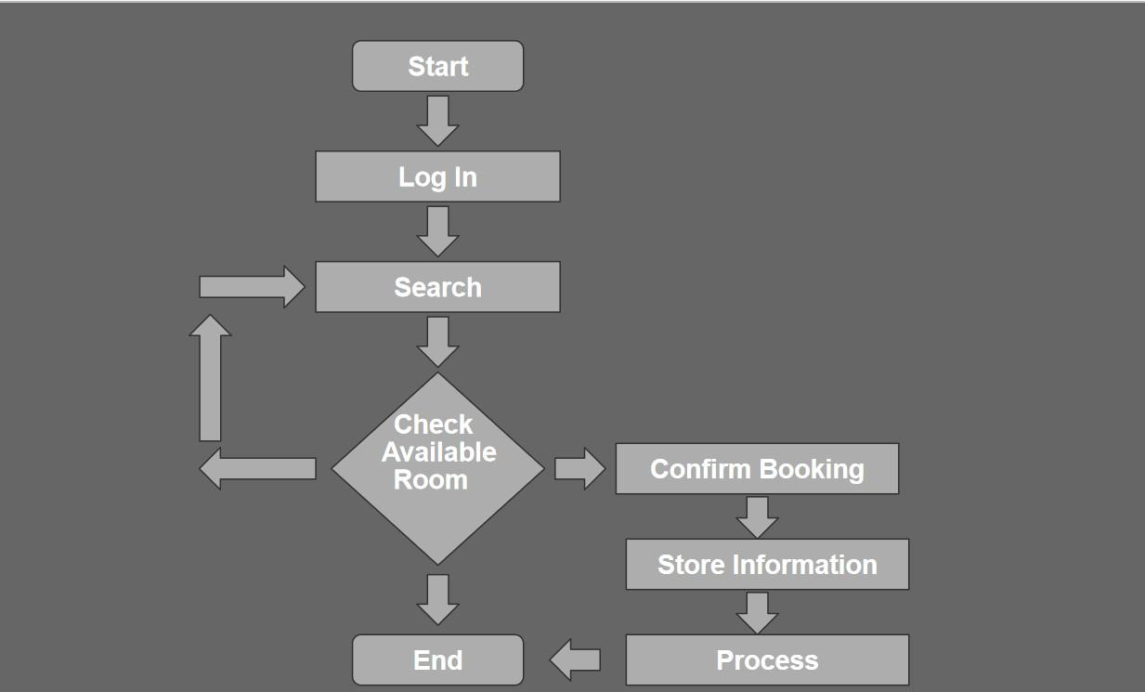

## 

## 

## 

### ER Diagram

An Entity-Relationship diagram is a visual representation that illustrates the entities within a system, their attributes, and the relationships between them. It is a modeling technique used in database design to depict the logical structure of a database system.

### 

### Data Flow Diagram (DFD)

A Data Flow Diagram (DFD) is a graphical representation that depicts the flow of data within a system or process. It shows how data moves from one entity to another, how it is processed or transformed, and where it is stored.

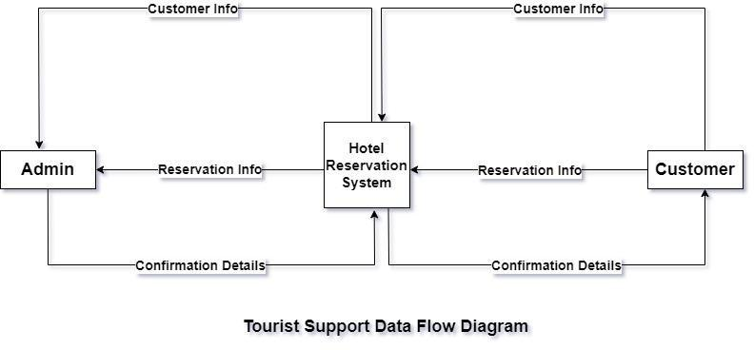

### Use Case [Diagram](https://docs.google.com/document/d/12-eIIk-2ZZTh1EYE5lu5bxaBqBN40pRw/edit#heading%3Dh.50yyiqfs7n2z)

Use Case Diagram is a visual representation that depicts the interactions between actors and a system or software application. It illustrates the various use cases or functionalities of the system and shows how actors interact with the system to achieve specific goals or tasks. Use case diagrams are commonly used in system analysis and design to capture user requirements and provide a high-level view of the system's functionality.

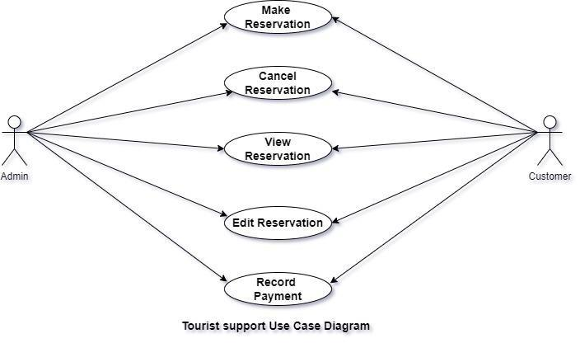

# Coding, Testing & Implementation:

## Coding:

**Register and Login Management (Authentication/Middleware):**

@app.route('/register', methods=['GET', 'POST'])

def register():

if request.method == 'POST':

# Extract form data and register user

return redirect(url_for('login'))

return render_template('register.html')

@app.route('/login', methods=['GET', 'POST'])

def login():

if request.method == 'POST':

# Validate credentials and login user

return redirect(url_for('dashboard'))

return render_template('login.html')

@app.route('/dashboard')

def dashboard():

if user_logged_in(): # Implement user session management

return render_template('dashboard.html', user=current_user)

return redirect(url_for('login'))

@app.route('/make_reservation', methods=['GET', 'POST'])

def make_reservation():

if not user_logged_in():

return redirect(url_for('login'))

if request.method == 'POST':

# Process reservation data

return redirect(url_for('dashboard'))

return render_template('make_reservation.html')

@app.route('/view_reservations')

def view_reservations():

if not user_logged_in():

return redirect(url_for('login'))

user_reservations = reservation_manager.get_user_reservations(current_user)

return render_template('view_reservations.html', reservations=user_reservations)

@app.route('/logout')

def logout():

# Implement logout logic and user session management

return redirect(url_for('index'))

**User Registration and Login:**

class User:

def __init__(self, username, password, email):

self.username = username

self.password = password

self.email = email

class UserManager:

def __init__(self):

self.users = []

def register_user(self, username, password, email):

user = User(username, password, email)

self.users.append(user)

def login(self, username, password):

for user in self.users:

if user.username == username and user.password == password:

return user

return None

**Reservation Management:**

class Reservation:

def __init__(self, user, room_type, check_in_date, check_out_date):

self.user = user

self.room_type = room_type

self.check_in_date = check_in_date

self.check_out_date = check_out_date

class ReservationManager:

def __init__(self):

self.reservations = []

def make_reservation(self, user, room_type, check_in_date, check_out_date):

reservation = Reservation(user, room_type, check_in_date, check_out_date)

self.reservations.append(reservation)

def get_user_reservations(self, user):

user_reservations = []

for reservation in self.reservations:

if reservation.user == user:

user_reservations.append(reservation)

return user_reservations

**Payment Processes:**

class PaymentGateway:

def process_payment(self, user, amount):

# Implement payment processing logic here

pass

**User Management:**

def main():

user_manager = UserManager()

reservation_manager = ReservationManager()

while True:

print("1. Register")

print("2. Login")

print("3. Make Reservation")

print("4. View Reservations")

print("5. Exit")

choice = input("Enter your choice: ")

if choice == "1":

username = input("Enter username: ")

password = input("Enter password: ")

email = input("Enter email: ")

user_manager.register_user(username, password, email)

print("User registered successfully!")

elif choice == "2":

username = input("Enter username: ")

password = input("Enter password: ")

user = user_manager.login(username, password)

if user:

print("Login successful!")

else:

print("Login failed!")

elif choice == "3":

if user:

room_type = input("Enter room type: ")

check_in_date = input("Enter check-in date: ")

check_out_date = input("Enter check-out date: ")

reservation_manager.make_reservation(user, room_type, check_in_date, check_out_date)

print("Reservation successful!")

else:

print("Please login first!")

elif choice == "4":

if user:

user_reservations = reservation_manager.get_user_reservations(user)

for reservation in user_reservations:

print(f"Room Type: {reservation.room_type}, Check-in: {reservation.check_in_date}, Check-out: {reservation.check_out_date}")

else:

print("Please login first!")

elif choice == "5":

print("Exiting the system.")

break

if __name__ == "__main__":

main()

## Implementation:

Setting Up the Environment:

First, make sure you have Python and Flask installed.

**Flask App:**

from flask import Flask, render_template, request, redirect, url_for

app = Flask(__name__)

# user and reservation management classes

@app.route('/')

def index():

return render_template('index.html')

if __name__ == '__main__':

app.run(debug=True)

**Index.html**

<!DOCTYPE html>

<html>

<head>

<title>Hotel Reservation System</title>

</head>

<body>

<h1>Welcome to the Hotel Reservation System</h1>

<a href="{{ url_for('login') }}">Login</a> |

<a href="{{ url_for('register') }}">Register</a>

</body>

</html>

**dashboard.html**

<!DOCTYPE html>

<html>

<head>

<title>Dashboard</title>

</head>

<body>

<h1>Dashboard</h1>

<p>Welcome, {{ user.username }}!</p>

<a href="{{ url_for('make_reservation') }}">Make Reservation</a> |

<a href="{{ url_for('view_reservations') }}">View Reservations</a>

<br><br>

<a href="{{ url_for('logout') }}">Logout</a>

</body>

</html>

## Testing and Quality Assurance

Quality assurance in a hotel reservation system project ensures that the system meets the required quality standards, functions as intended, and satisfies the needs of stakeholders. It involves a set of processes and activities aimed at preventing defects, identifying issues, and improving the overall quality of the system. Here are some key aspects of quality assurance in a hotel reservation system project:

* + - Requirement Validation: QA starts with validating the requirements of the system. This involves reviewing and analyzing the documented requirements to ensure they are clear, complete, and aligned with stakeholders' expectations. Any ambiguities or inconsistencies are identified and resolved early on.
    - Test Planning and Execution: includes creating a comprehensive test plan that outlines the testing approach, test cases, and test data. Test scenarios cover various aspects of the system, including user interface, functionality, performance, security, and integration. Tests are executed to verify that the system behaves as expected, and any issues or defects are identified, logged, and addressed.
    - Functional and Non-functional Testing: QA involves conducting thorough functional testing to validate that all system functionalities, such as search, reservation, payment processing, and cancellation, are working correctly. Non-functional testing focuses on aspects like performance, security, usability, accessibility, and compatibility. This ensures that the system performs well, is secure, user-friendly, and compatible with different devices and browsers.
    - Usability Testing: Usability testing evaluates the user experience of the hotel reservation system. It involves observing and collecting feedback from users to assess the system's ease of use, intuitiveness, and overall user satisfaction. Usability issues are identified and addressed to improve the user interface and enhance the overall user experience.
    - Security and Privacy Assessment: QA includes assessing the system's security measures to ensure that user data, including personal and financial information, is adequately protected. Security vulnerabilities are identified and mitigated to maintain the confidentiality, integrity, and availability of sensitive data.
    - Performance Testing: Performance testing measures the system's response time, scalability, and stability under expected and peak loads. This ensures that the system can handle a large number of concurrent users and maintain optimal performance. Performance bottlenecks are identified and addressed to ensure a smooth user experience.
    - System Integration Testing: QA involves testing the integration points between the hotel reservation system and other external systems, such as payment gateways, property management systems (PMS), or online travel agencies (OTAs). This ensures that data is accurately exchanged and synchronized, and the system functions seamlessly with other systems.
    - Defect Tracking and Management: QA includes establishing a robust defect tracking and management process. Defects and issues discovered during testing are logged, prioritized, and assigned for resolution. Regular communication and collaboration with the development team ensure that defects are addressed promptly and effectively.
    - Continuous Improvement: QA aims to foster continuous improvement throughout the project lifecycle. Lessons learned from testing, user feedback, and system performance are documented and shared with the development team for process refinement and future enhancements.
    - Documentation and Compliance: QA involves ensuring that all necessary documentation, such as test plans, test cases, and user manuals, are prepared and maintained. Compliance with industry standards, regulations, and data privacy laws is also ensured.